**Parameter Values:**

|  |  |  |  |  |  |  |  |  |  |
| --- | --- | --- | --- | --- | --- | --- | --- | --- | --- |
| **f0 (MHz)** | **h (mm)** | **Radius** | **Feed Position** | **Slot Length** | **Slot Width** | **Slot Separation** | **f2** | **f1** | **Bandwidth** |
| 1200 | 13 | 61 | -20.5 | 46.5 | 7 | 33 | 1.4067 | 1.2308 | 0.1759 |
| 1300 | 12 | 56.3 | -18 | 43 | 6 | 32 | 1.5185 | 1.3274 | 0.1911 |
| 1600 | 13 | 44 | -23 | 51 | 5 | 25 | 1.8584 | 1.6028 | 0.2556 |
| 1700 | 12 | 41 | -11 | 31.5 | 6 | 22 | 2.0254 | 1.7671 | 0.2583 |
| 1800 | 12 | 39 | -15 | 31 | 5 | 29 | 2.194 | 1.861 | 0.333 |

**1200 MHz, 13mm (0.05)**

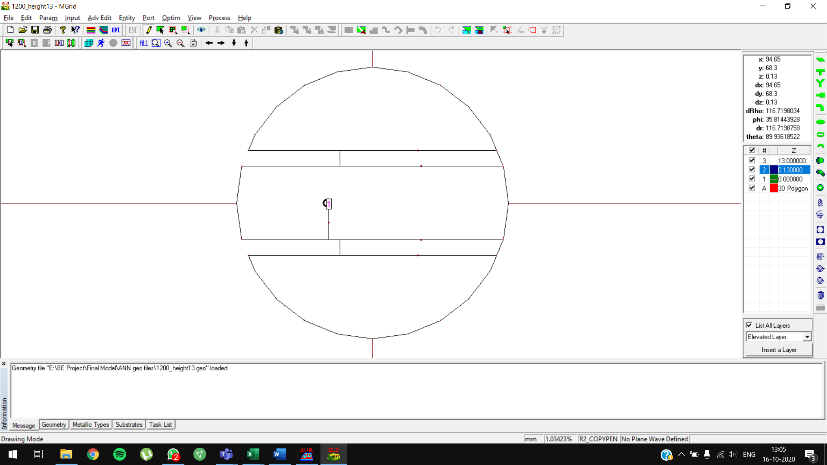

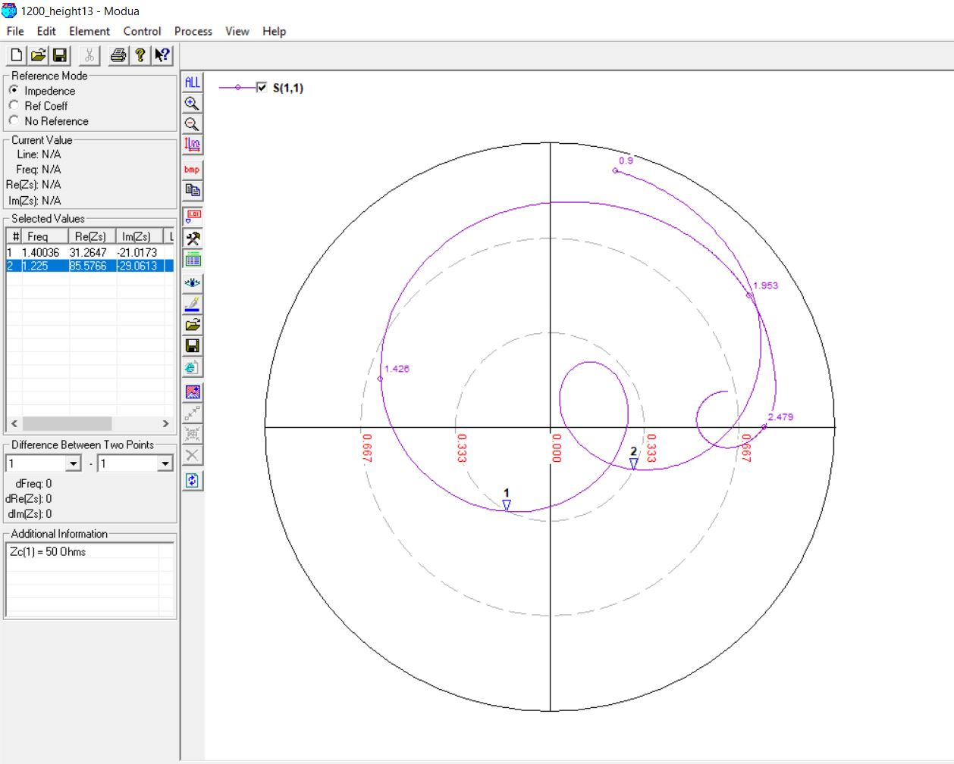

**1300 MHz, 12mm (0.05)**

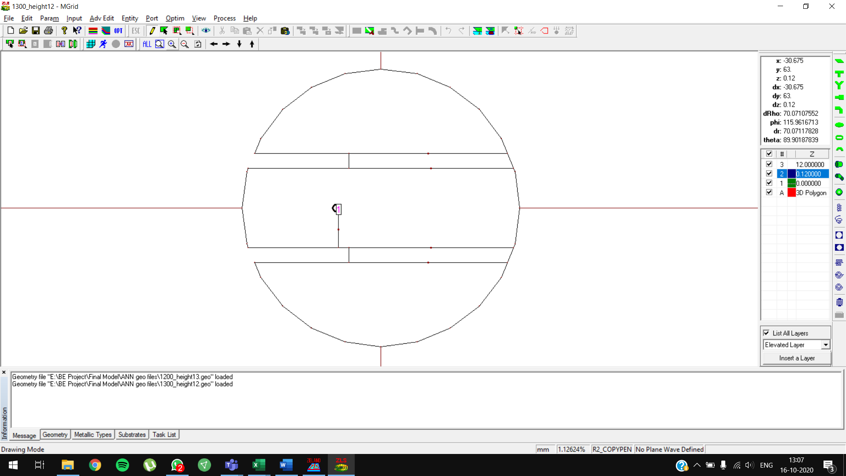

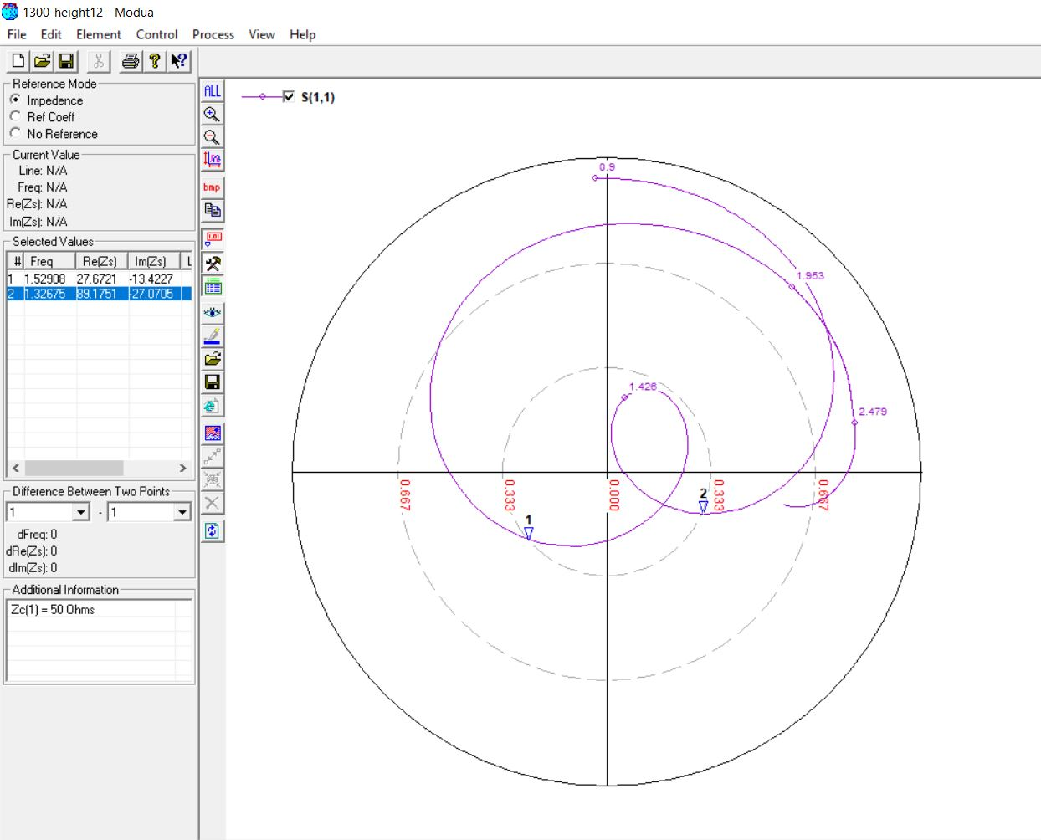

**1600 MHz, 13mm (0.07)**

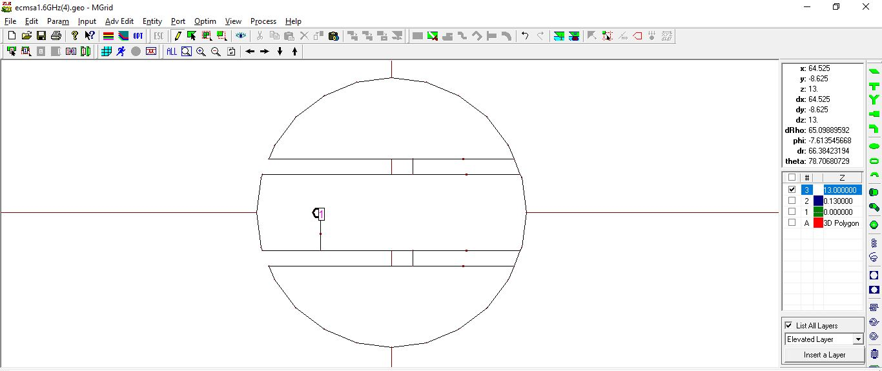

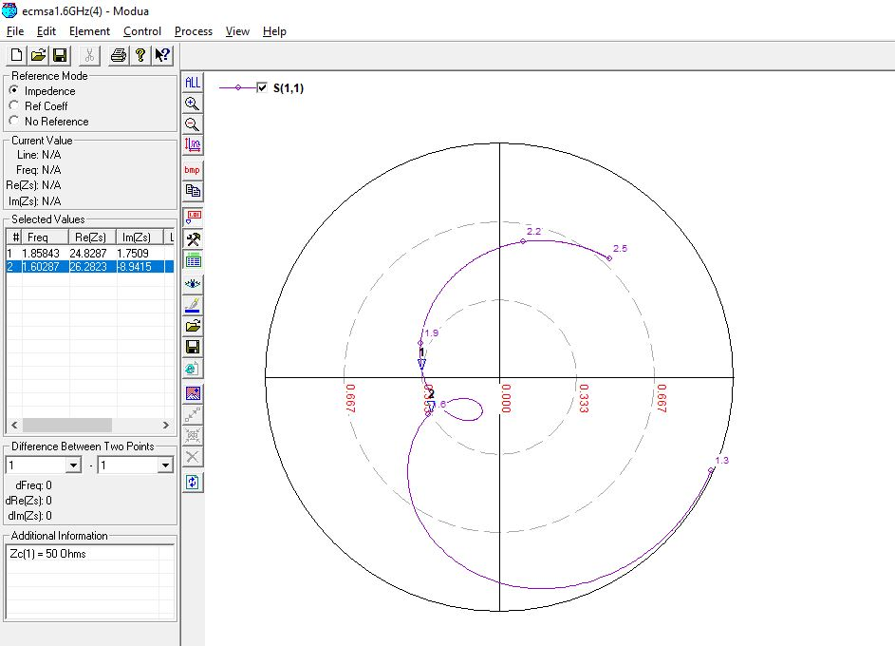

**1700 MHz, 12mm (0.07)**

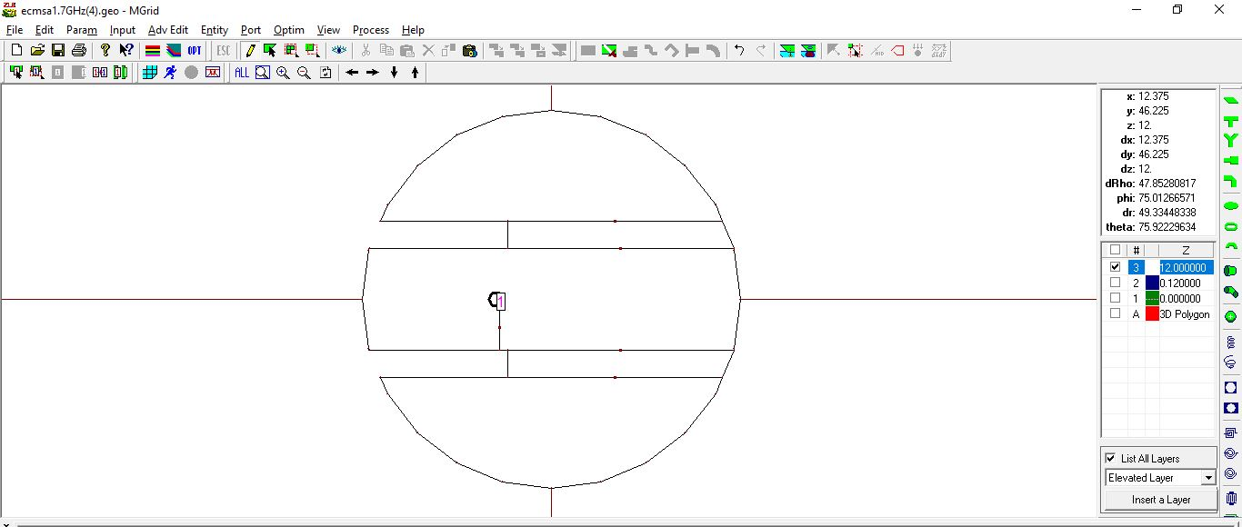

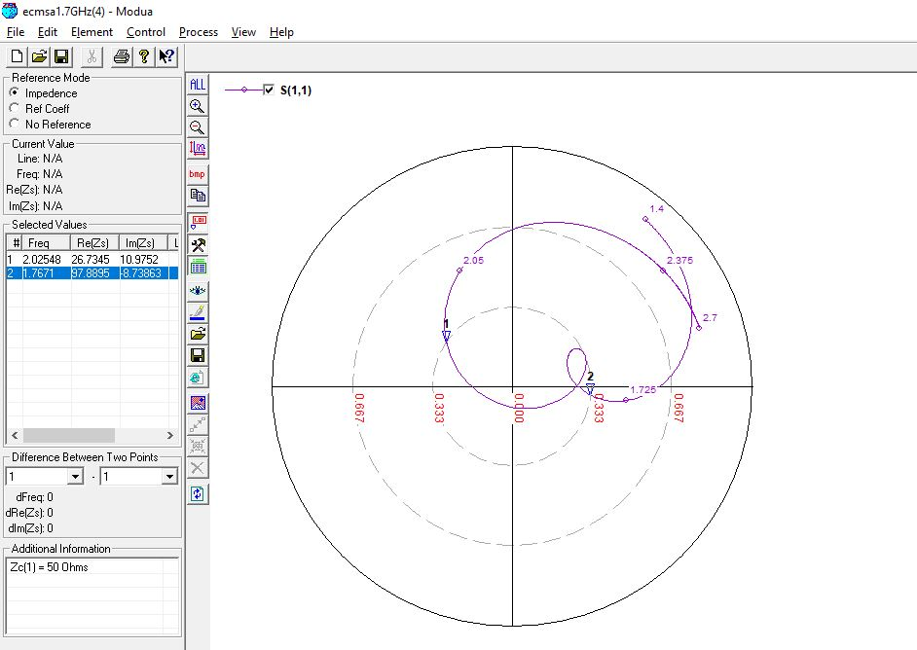

**1800 MHz, 13mm (0.07)**

